Physics (8)
Homework (1)

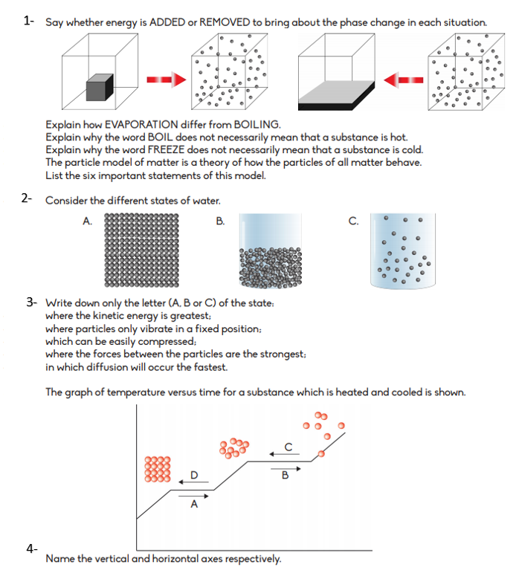

Instructions:
1- The homework should be submitted in school before the 12th of November and for the students outside the country to the teachers email (sahargnieber@yahoo.com)
2- The homework should be written in your notebook.

