أولاً: القراءة والاستيعاب
- وسائل التواصل الاجتماعي
- العواصف الرملية
انظر المرفق

التوكيد

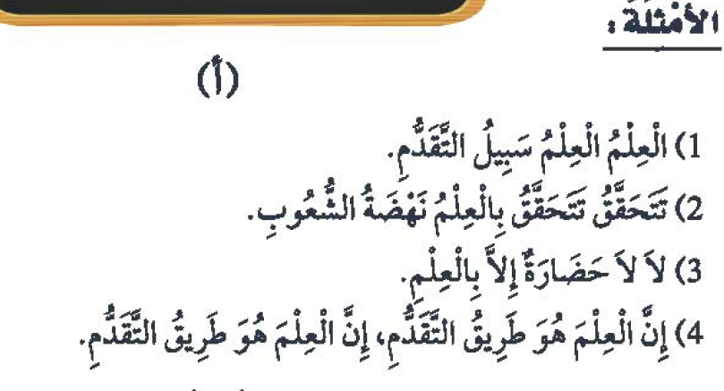

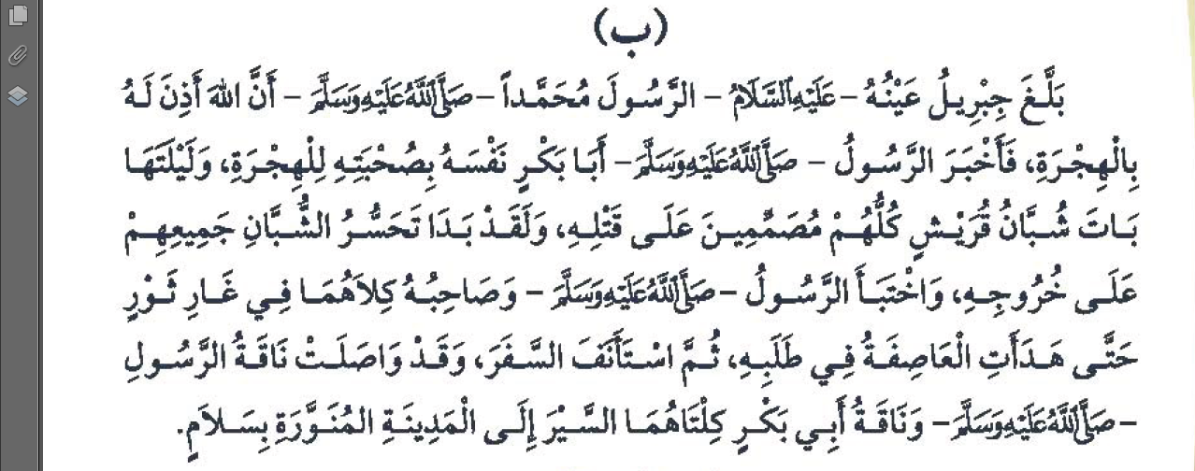

القاعدة:

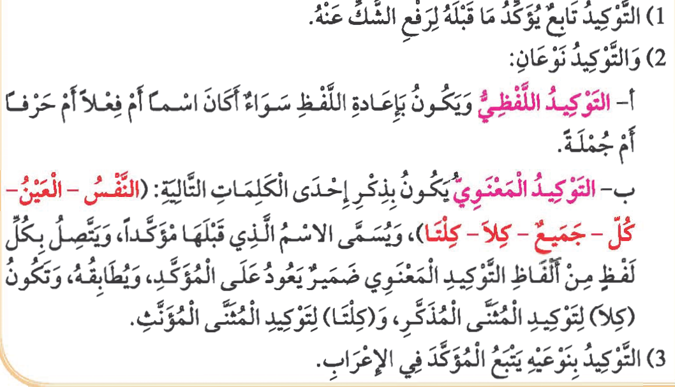
التدريبات

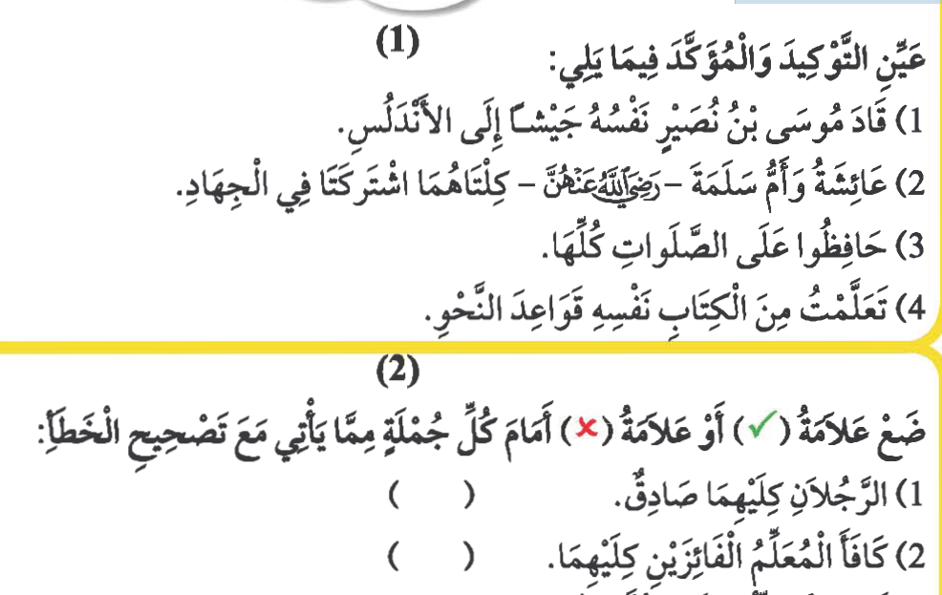
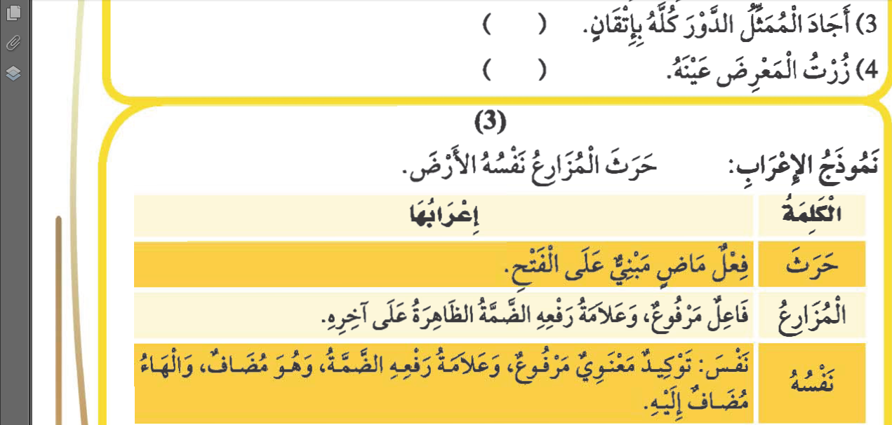
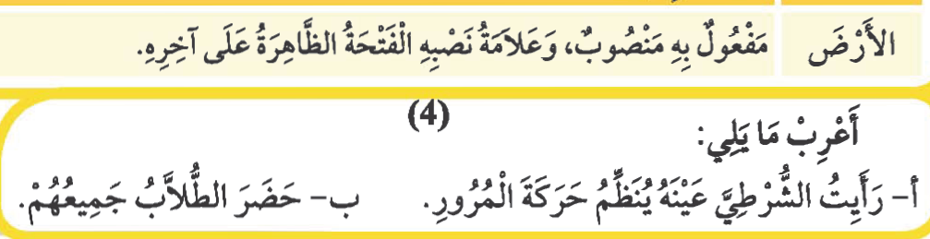

العطف (مراجعة)
المعطوف: هو تابع يذكر معطوفاً على ما قبله بحرف من حروف العطف.
حروف العطف: ( و – حتى - ف – ثم – أو – أم – لا – بل – لكن )
الأمثلة ونموذج الإعراب
أنظر الكتاب ص 136

التدريبات
انظر الكتاب ص 137

Islamic Studies
The Delegation
In the eleventh year of Prophet hood, while the prophet (blessings and peace be upon him) was at Aqabah, he met a group of men from Madinah (at that time known as Yathrib) and invited them to Islam. They were neighbors of the Jews and had heard mention of a Prophet, who was about to come. After some deliberation they accepted his teachings and became Muslims.
The following year, twelve people from Madinah met the prophet and gave him their pledge that they would believe in one God and worship Him alone. They also pledged that they would not steal or kill their children. This undertaking is known as the First Pledge of Aqabah. The prophet (blessings and peace be upon him) sent Mus’āb bin Umayr with them. Mus’āb was a handsome young man who was a proficient reciter of the Qur’ān. He accompanied them to Madinah, preached Islam to the people, and led them in prayer.
The next year, Mus’āb bin Umayr (may Allah be pleased with him) returned to Makkah with seventy-three men and two women from Madinah. They all met with the Prophet, pledged their allegiance to him and promised to protect him and the other Muslims. This is known as the Second Pledge of Aqabah.

The Prophet's Migration
After the second pledge of Aqabah, the prophet (blessings and peace be upon him) ordered the Muslims who were with him in Makkah to leave for Madinah. He could no longer tolerate their suffering at the hands of the Quraysh. The emigration from Makkah to Madinah was not easy. The Quraysh put many obstacles to prevent the Muslims from leaving Makkah. Some were forced to leave their wives and children behind, and to travel alone. Others had to leave all of their wealth and belongings and travel empty handed.
On the 27th of Safar in the 14th year of Prophet hood (622 C.E.), Allah granted permission to the Prophet to travel to Madinah. Abu Bakr, the Prophet’s close friend, accompanied him on this blessed and historical journey. On the eve of that day, the Quraysh had gathered to make one final attempt to assassinate the Prophet. They agreed that each tribe would provide a young man and together they would attack the Prophet, each man striking a blow. Allah informed His Messenger of this plot, and so he (blessings and peace be upon him) secretly left the house without the men of Quraysh noticing him. Over the years, the prophet acquired such a reputation for honesty that the disbelieving Quraysh would leave their valuables with him to look after. Before leaving, the Prophet (blessings and peace be upon him) charged Ali with the responsibility of returning all the properties to their rightful owners.

