Year10 English homework due 19.11.2020

Refer to your Philip Allen notes on Romeo and Juliet page 15.
Answer both questions in the "Text Focus" box as I explained in the lesson. Refer to attachment.

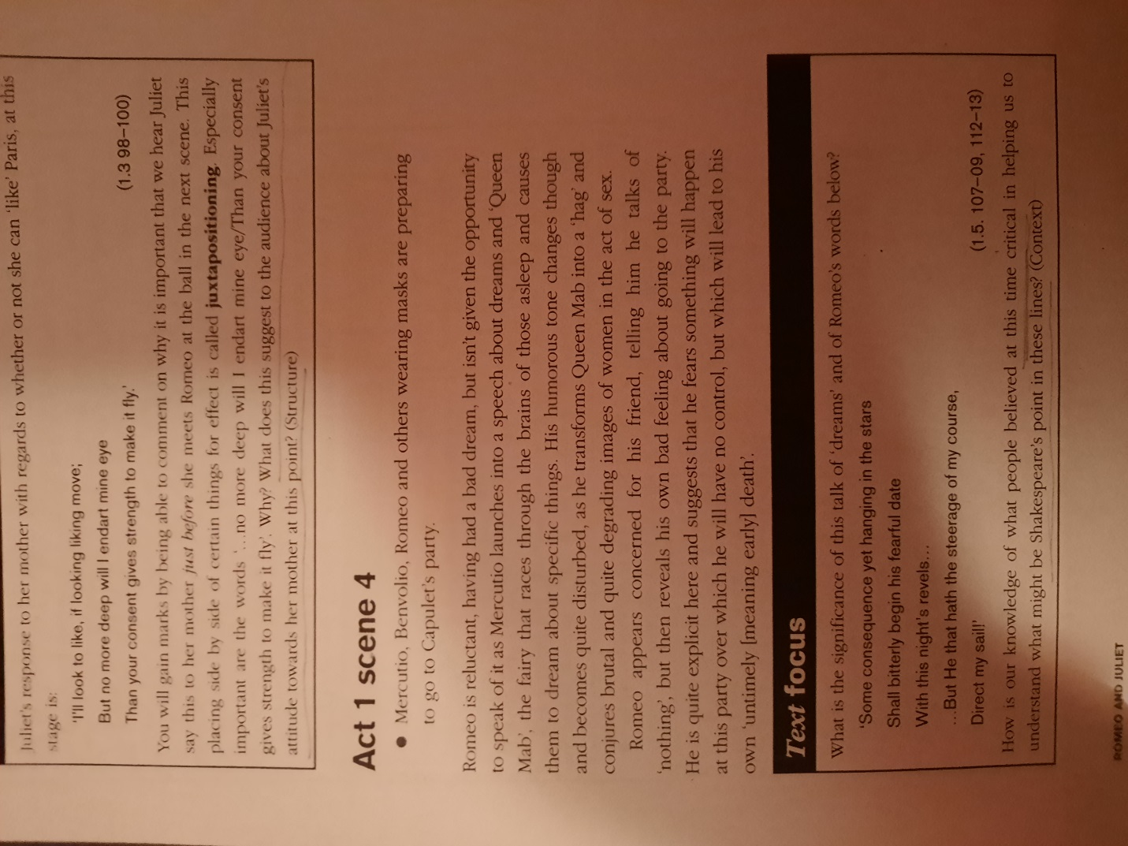

Mrs. Mary

