Physics (7)
Homework (1)

- Figure(1) shows how much energy you daily need, if you are only eating McDonalds (and this isn’t healthy) prepare your daily meal according to figure (2).

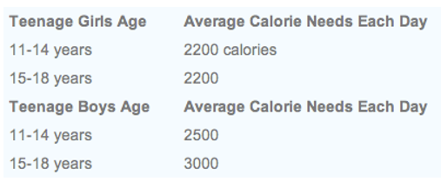
Figure(1) Average Calorie needs each day

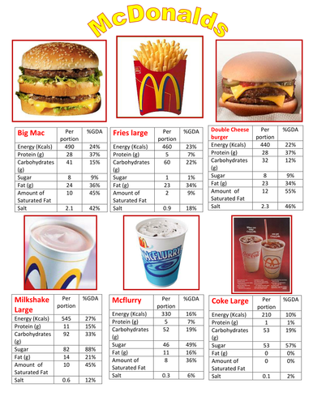
Figure(2) Average Calorie McDonald’s

- Solve questions 2, 3, 4 page 139 from your book.

Instructions:
1- The homework should be submitted in school before the 12th of November and for the students outside the country to the teachers email (sahargnieber@yahoo.com)
2- The homework should be written in your notebook.
Good luck

