***Maths Homework :04***

Year: 8

Student Name: ________________ Date: 22/10/2020

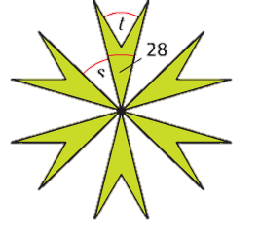

***S***

**🢧 This pattern has rotational symmetry of order 6**

a) Calculate the size of angle ***s***

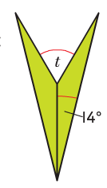

**🢧 Each quadrilateral in the pattern is an arrowhead made up of two   
 congruent isosceles triangles**

b) Calculate the size of angle ***t***