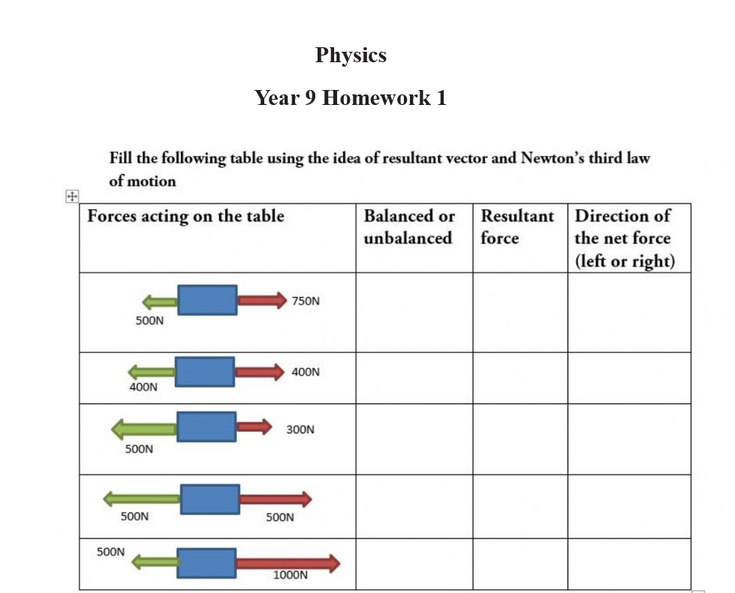
Instructions:
The homework should be submitted in school (in your notebook) before the 12th of November and for the students outside the country to the teachers email (sahargnieber@yahoo.com).

